Budget Rent A Car 
of British Columbia

Global Information System

Rate Control Business Design

Version 2.00

Note: The information contained in this document is confidential and may not be disclosed to any parties outside of Budget Rent a Car of British Columbia without written consent by one of its officers.
Copyright (C) 2000 Budget Rent a Car of British Columbia
Table of Contents
1. Functional Area Business Design 1
1.1. Rate Control 1
1.1.1. Process Description 1
1.1.2. Screens 2
1.1.2.1. Vehicle Rate Maintenance 2
1.1.2.1.1. Vehicle Rate Maintenance – General Tab 5
1.1.2.1.2. Vehicle Rate Maintenance – Rate Amount Tab 10
1.1.2.1.3. Vehicle Rate Maintenance – Restrictions Tab 14
1.1.2.1.4. Vehicle Rate Maintenance – Inclusions Tab 17
1.1.2.2. Rate Search 25
1.1.2.3. Location Maintenance 28
1.1.2.3.1. Location Maintenance – General Tab 30
1.1.2.3.2. Location Maintenance – Address/Hours Tab 34
1.1.2.3.3. Location Maintenance – Drop Off Location Tab 37
1.1.2.3.4. Location Maintenance – Walk Up Rate Tab 40
1.1.2.3.5. Location Maintenance – Reservation Rate Tab 43
1.1.2.4. Optional Extra Maintenance 49
1.1.2.5. Optional Extra Maintenance – LDW Deductibles 53
1.1.2.6. Sales Accessory Maintenance 55
1.1.2.7. Exchange Rate Maintenance 59
1.1.3. Reports 62
1.1.4. Background Processes 62
1.1.5. Test Scenario List 62
1.1.6. Controls & Audit Trails 63
1.1.7. Security Requirements 63
1.1.8. Business Transaction Volumes 63
1.1.9. Tables without Maintenance Screens 63
1.1.10. System Values Table Entries 63
1.1.11. Data Model 64
2. Revision History 65
2.1. Version 2.00 65

Functional Area Business Design

Rate Control

Process Description
Rates can be classified into three segments: Local, BCD, and Maestro rates. Local rates are those rates that are defined and stored locally by Budget BC. Local rates are created, stored, and updated in GIS and are only available through the Vancouver Reservation Centre and the individual Lower Mainland locations. BCD rates are the rates assigned to organizations at the Budget Corporate level. BCD rates are kept in GIS for use. There is no facility in GIS to enter, store or retrieve Maestro rates beyond what is provided for local and BCD rates.
GIS provides the following facilities for the entry, storage and retrieval of Local rates and BCD rates:
- Vehicle Rate Maintenance (Screen)
- Rate Search (Screen)
- Location Maintenance (Screen)
- Optional Extra Rate Maintenance (Screen)
- LDW Deductible Maintenance (Screen)
- Sales Accessory Rate Maintenance (Screen)
- Exchange Rate Maintenance (Screen)

Screens

Vehicle Rate Maintenance
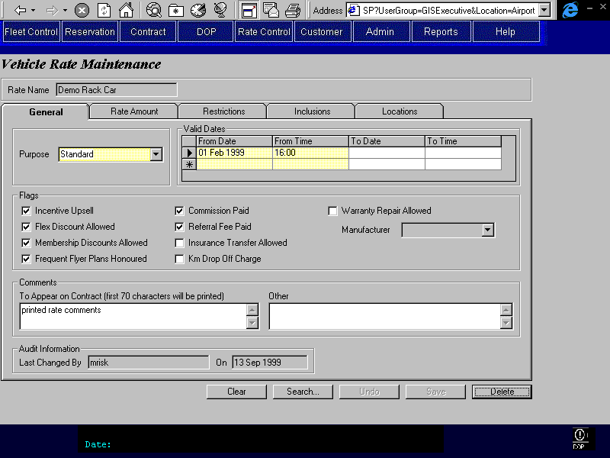
Purpose
This screen allows for the definition of rates for vehicle rentals.
There are five tabs available. A description of each tab is provided below. The tabs include:
General: Where general information about the rate is entered and flags set.
Rate Amount: Where rate amounts are defined by time period, vehicle class, and level.
Restrictions: Where rate restrictions are assigned to the rate.
Inclusions: Where optional extras, sales accessories, and taxes are selected to be included in the rate.
Locations: Where pick up locations, drop off locations and location specific charges are defined for the rate.
Navigation
N/A
Functions
N/A
Controls
Field | Source | Req* | Validation | Comments
Rate Name | Vehicle Rate, Rate Name | Y | Must be unique and is not updateable after creation. | This will be the primary identifier by which the user will identify the rate.
Technical Notes
Rate Date Model and History
The relationships shown between the Rate Control entities (Vehicle Rate and all of its children) in the logical data model are for descriptive purposes and do not exist in the physical database. The propagation of the Rate Name (or Rate ID) key remains the same in the physical model, however, the Rate Created On key is replaced by Effective Date. The Effective Date exists in each rate control entity but is not a foreign key from the Vehicle Rate entity.
Logical Model:
Vehicle Rate
- Rate Name (PK)
- Effective Date
for Vehicle Rate
- Termination Date
for Vehicle Rate
Rate Level
- Rate Name(FK)(PK)
- Effective Date
for Rate Level
- Termination Date
for Rate Level

Physical Model:
Vehicle Rate
- Rate ID (PK)
- Effective Date (PK)
for Vehicle Rate
- Termination Date
for Vehicle Rate
Rate Level
- Rate ID(FK)(PK)
- Effective Date (PK)
for Rate Level
- Termination Date
for Rate Level

The elimination of the propagation of the Vehicle Rate Effective Date (and therefore the relationship) in the physical model allows for a more efficient storage of history. In the Rate Control tables the Effective Dates and Termination Dates are used to maintain the history of Rate changes. When looking up a rate that has been assigned to a reservation or contract, the Reservation.Date Rate Assigned or Contract.Rate Assigned Date along with the Rate ID should always be used to find the appropriate record in any of the Rate Control tables. When selecting a rate not yet assigned to the reservation or contract, the current date and Rate ID will be used.

Vehicle Rate Maintenance – General Tab
Purpose
The purpose of this tab is to define basic information about the rate. This includes the rate purpose, valid from and to dates, comments, and standard flags. Audit information, which applies to the entire rate, is displayed at the bottom of the tab.
The purpose field is a descriptive field that is used to identify the business purpose of the rate. If the rate purpose is ‘Tour’ then a message will be displayed on the next tab and there will be restrictions on what rate periods are printed.
The valid from and to dates control when the rate may be used for rentals. Two sets of comments are provided; one that will appear on the contract and a second that will appear only on this screen.
The flags available are as follows:
- Incentive Upsell: specifies whether an upsell should be encouraged when using this rate.
- Flex Discount Allowed: specifies whether reservation agents or customer service agents may apply a flex discount to a reservation or contract when using this rate.
- Membership Discounts Allowed: specifies whether membership discounts, such as BCAA, will be honoured when using this rate.
- Commission Paid: specifies whether or not commissions are paid when using this rate.
- Referral Fee Paid: specifies whether or not referral fees are paid when using this rate.
- Frequent Flyer Plans Honoured: specifies whether frequent flyer plans will be honoured when using this rate.
- Insurance Transfer Allowed: specifies whether insurance transfers are allowed when using this rate.
- Km Drop Off Charge: specifies whether regular, automatically calculated drop charges will be applied to this rate or whether manually calculated drop charges will apply (used for provincial government).
- Warranty Repair Allowed: specifies whether this rate is used for warranty repairs, if so then the manufacturer name must be entered.
Navigation
N/A
Functions
N/A
Controls
Field | Source | Req* | Validation | Comments
Rate Purpose | Vehicle Rate, Rate Purpose ID | Y | Value controlled by Rate Purpose table. | If purpose is ‘Tour’ display tour rate message on next tab (defined in next section).
Valid From (date) | Rate Availability, Valid From | S | Date | At least one Valid From date must be entered for a rate.
Valid From (time) | Rate Availability, Valid From | Y | 24 hour clock | Required if Valid From date is entered for row, otherwise disabled.  Default: 00:00
Valid To (date) | Rate Availability, Valid To | S | Date  Cannot overlap another record. | Required if there is a record with a more recent Valid From date.
Valid To (time) | Rate Availability, Valid To | S | 24 hour clock | Required if Valid To date is entered for row, otherwise disabled.  Default: 23:59
Incentive Upsell | Vehicle Rate, Upsell | N | Flag | Default: Yes
Flex Discount Allowed | Vehicle Rate, Flex Discount Allowed | N | Flag | Default: Yes
Membership Discounts Allowed | Vehicle Rate, Discount Allowed | N | Flag | Default: Yes
Referral Fee Paid | Vehicle Rate, Referral Fee Paid | N | Flag | Default: Yes
Commission Paid | Vehicle Rate, Commission Paid | N | Flag | Default: Yes
Frequent Flyer Plans Honoured | Vehicle Rate, Frequent Flyer Plans Honoured | N | Flag | Default: Yes
Insurance Transfer Allowed | Vehicle Rate, Insurance Transfer Allowed | N | Flag | Default: Yes
Km Drop Off Charge | Vehicle Rate, Km Drop Off Charge | N | Flag | Default: Yes
Warranty Repair Allowed | Vehicle Rate, Warranty Repair Allowed | N | Flag | Default: Yes
Manufacturer | Vehicle Rate, Manufacturer ID | S | Value controlled by Manufacturer table. | Required when Warranty Repair Flag is Yes, otherwise disabled. Manufacturer Name is displayed.
Comments To Appear on Contract | Vehicle Rate, Contract Remarks | N | Free form text.
Comments Other | Vehicle Rate, Other Remarks | N | Free form text.
Last Changed By | Vehicle Rate, Last Changed By | D
Last Changed On | Vehicle Rate, Last Changed On | D
Technical Notes
Valid From / Valid To:
- Backdating is not allowed
- No overlap allowed between Valid From and To periods
- Contiguity is not required

Vehicle Rate Maintenance – Rate Amount Tab
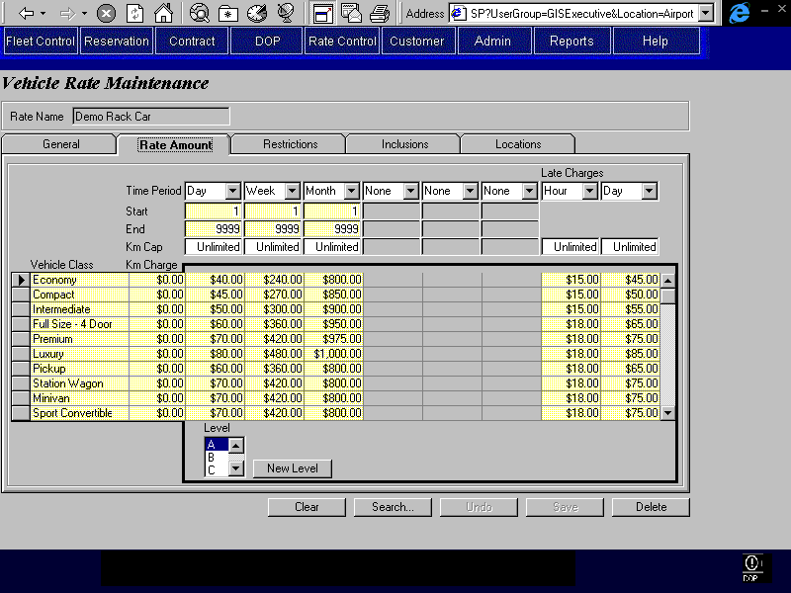
Purpose
This tab allows for the definition of rate information that varies by vehicle class, time period, rate level.
A matrix is provided in which to define the dollar amount charged by vehicle class per defined time period. These dollar amounts also vary by level. Each rate may have multiple levels, which are sequentially named A to Z.
Defined levels for the rate are displayed in the Level list box. New levels may be defined by pressing the ‘New Level’ button. Upon pressing the ‘New Level’ button the next sequential level will be added and the dollar amounts will be blank, waiting for entry. Levels cannot be deleted using this screen. The applicable classes will be available for each level.
The time periods are defined in the first three rows. For each time period (except for Flat, AM, PM, OV), a start and end numeric value must be entered. For Flat, AM, PM, and OV time periods, the start and end fields are set to 1 and locked. A kilometre cap for each time period is also entered. The time periods, associated kilometre caps, and associated start and end values are constant for the rate, regardless of level or tour class.
For the same time period, the start and end periods cannot overlap and must be continuous between the time periods. For example, for two time periods of day, start and end values of 1 to 6 and 7 to 10 is allowable, but 1 to 6 and 8 to 10 is not allowed because there is a gap between the start and end sets. Also not allowed would be 1 to 6 and 3 to 10 because there is an overlap between the start and end sets.
For regular time periods of day, week and month, when defined, one start value for each of these types of time period must be ‘1’. This ensures that day, week, and month time periods, if defined, are defined starting at one.
For regular time periods, at least one time period must have an End value of ‘9999’.
If a new time period is added, it will be added for all the existing levels for the rate, not just the one that is currently displayed. The rate dollar amounts will be defaulted to $99,999.99 A warning will be displayed to remind the user that rate dollar amounts should be set for each level that they will want to use in the future.
The vehicle classes are selected in the first column. With each vehicle class a kilometre charge is entered. The vehicle classes and kilometre charges associated with them are constant for the rate regardless of level.
The first six time period columns are for the definition of regular rates. Late time periods, kilometre caps, and dollar amounts may be defined in the last two columns.
For rate set-up assumptions used for calculations see the Rental Calculation Function in the Contract Part 1 Business Design document.
Navigation
N/A
Functions
New Level: Allows the user to add a new level to the list of already defined levels. Automatically adds the next sequential level name.
Note: The method for calculating the total Rate Amount for a vehicle rental is defined in the Contracts Part One document.
Controls
Field | Source | Req | Validation | Comments
Time Period | Rate Time Period, Time Period | Y | Value controlled by Time Period table. | At least one Time Period with Type = Regular must be specified per rate. A Start and End value must be defined for each Time Period defined. Start and End periods for time periods of the same value and Type cannot overlap and must be continuous between Time Periods.
Start | Rate Time Period, Time Period Start | S | Numeric | Required when Time Period is entered for the column and Time Period value is not ‘Flat’.
End | Rate Time Period, Time Period End | S | Numeric | Required when Time Period is entered for the column and Time Period value is not ‘Flat’.
Km Cap | Rate Time Period, Km Cap | S | Numeric or ‘Unlimited’ | Default: Unlimited  Required when Time Period is entered for the column.
Vehicle Class | Rate Vehicle Class, Vehicle Class Code | Y | Value controlled by Vehicle Class table. | At least one Vehicle Class must be specified per rate. Vehicle Class Name is displayed.
Km Charge | Rate Vehicle Class, Per Km Charge | S | Currency | Default: 0  Required when Vehicle Class is entered for the row.
Rate Dollar Amount (matrix) | Rate Charge Amount, Amount | S | Currency | Required when Vehicle Class and Time Period are entered for the cell.  Rate Charge Amount, Type = Regular
Late Charge Dollar Amount (matrix) | Rate Charge Amount, Amount | S | Currency | Required when Vehicle Class and Time Period are entered for the cell.  Rate Charge Amount, Type = Late
Level | Rate Level, Rate Level | Y | A to Z | Show only the already defined levels in the drop down list.
(tour rate message) |  | D |  | “Tour Rate: The first three Rate columns will be hidden on the printed contract.” Only displayed when Rate Purpose is Tour.
Technical Notes
When the following fields are changed, they change for all levels: Vehicle Class, Km Charge, Time Period, Start, End, and Km Cap. Changing these fields will not automatically affect the dollar amount fields; these must be manually updated.

Vehicle Rate Maintenance – Restrictions Tab
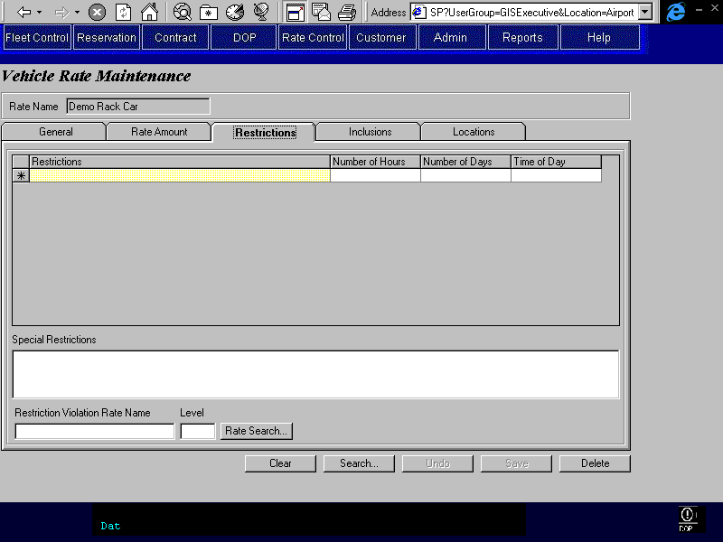
Purpose
This tab allows for restrictions to be applied to the rate and for a second rate to be specified for use when the restrictions have been violated.
Restrictions are selected from a predetermined set and are automatically. Some selected Restrictions may also be associated with a number of hours, number of days, or time. Special Restrictions are free text and are not automatically enforced-. The Restriction Violation Rate is the rate that will be used if any of the selected Restrictions are violated. It may also be manually applied if the Special Restriction is violated. If the violation rate is used, it will be applied to the entire rental period.
Navigation
Rate Search: Invokes the rate search screen and returns selected rate to the violation rate field.
Functions
N/A
Note: The rules for enforcing Restrictions are defined in the Rental Calculation Function in the Contracts Part One document.
Controls
Field | Source | Req* | Validation | Comments
Restrictions | Rate Restriction, Restriction ID | N | Value controlled by Restriction table. | Restriction name is displayed.
Number of Hours | Rate Restriction, Number of Hours | S | Numeric | Required for Restrictions where Restriction.Hour_Restriction is Yes.
Number of Days | Rate Restriction, Number of Days | S | Numeric | Required for Restrictions where Restriction.Day_Restriction is Yes.
Time of Day | Rate Restriction, Time of Day | S | 24 hour clock | Required for Restrictions where Restriction.Time_Restriction is Yes.
Special Restrictions | Vehicle Rate, Special Restrictions | N | Free form text
Restriction Violation Rate Name | Vehicle Rate, Violation Rate ID | N | Value controlled by the Vehicle Rate Level table (not a drop down). Violation Rate must be valid during the entire time the specified Rate is valid. | Rate name is displayed.
Level (Restriction Violation Rate) | Vehicle Rate, Violation Rate Level | N | Value controlled by the Vehicle Rate Level table (not a drop down). Violation Rate must be valid during the entire time the specified Rate is valid
Technical Notes

Vehicle Rate Maintenance – Inclusions Tab
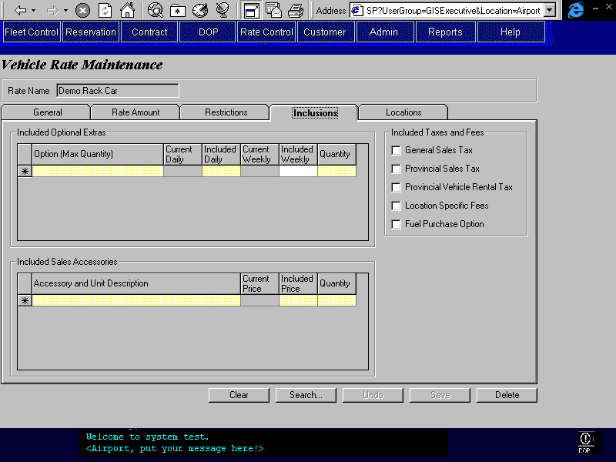
Purpose
This tab allows for the selection of Optional Extras (including LDW and Third Party Insurance), Sales Accessories, and Taxes to be included in the Rate at no additional charge.
When an optional extra is selected to be included in the rate, then a quantity and included rates must also be specified. A maximum quantity for each optional extra will control the maximum value allowable for the quantity. For example, only one LDW may be purchased.
For sales accessory there is a unit description that is displayed, which defines how or in what unit the sales accessory is sold. Like optional extras, when a sales accessory is selected to be included in the rate, a quantity and included price must be entered to specify how many units are to be included. There are no maximum quantities for sales accessories.
Taxes, locations fees, and FPO may also be included in the rate at no extra charge. Each tax and the location fee and FPO may be selected by checking the applicable box to include the item in the rate.
Navigation
N/A
Functions
N/A
Controls
Field | Source | Req* | Validation | Comments
Included Optional Extras
Option(Max Quantity) | Included Optional Extra, Optional Extra ID | N | Value controlled by the Optional Extra table. | Optional Extra name is displayed. Optional Extra, Maximum Quantity is displayed in brackets following the name. Only one of Optional Extra, Type = LDW, may be selected.
Current Daily | Optional Extra Price, Daily Rate | D |  | Currently valid daily rate for selected optional extra.
Included Daily | Included Optional Extra, Included Daily Amount | Y | Value must be less than or equal to Current Daily value.  Currency
Current Weekly | Optional Extra Price, Weekly Rate | D |  | Currently valid weekly rate for the selected optional extra.
Included Weekly | Included Optional Extra, Included Weekly Amount | S | Value must be less than or equal to Current Weekly value.  Currency | Required if Current Weekly field is populated. Otherwise no entry allowed.
Quantity (optional extra) | Included Optional Extra, Quantity | S | Numeric  Must be less than Optional Extra, Maximum Quantity | Default to 1 if Optional Extra is entered for the row.  Required if Optional Extra is entered for the row.
Included Sales Accessories
Accessories and Unit Description | Included Sales Accessory, Sales Accessory ID | N | Value controlled by the Sales Accessory table. | Sales Accessory name and Unit Description shown in selection list.
Current Price | Sales Accessory Price, Price | D |  | Currently valid price for selected sales accessory.
Included Price | Included Sales Accessory, Included Amount | Y | Value must be less than or equal to Current Price value.  Currency
Quantity (sales accessory) | Included Sales Accessory, Quantity | S | Numeric | Default to 1 if Sales Accessory entered for row.  Required if Sales Accessory is entered for the row.
Included Taxes and Fees
General Sales Tax | Vehicle Rate, GST Included | Y | Flag | Default: No
Provincial Sales Tax | Vehicle Rate, PST Included | Y | Flag | Default: No
Provincial Vehicle Rental Tax | Vehicle Rate, PVRT Included | Y | Flag | Default: No
Location Specific Fees | Vehicle Rate, Location Fee Included | Y | Flag | Default: No
Fuel Purchase Option | Vehicle Rate, FPO Included
Technical Notes
Optional Extras:
Only one of any optional extra can be selected. The quantity field is used to control the number of each included optional extra.
Sales Accessories:
Only one of any sales accessory can be selected. The quantity field is used to control the number of each included sales accessory.
Vehicle Rate Maintenance – Locations Tab
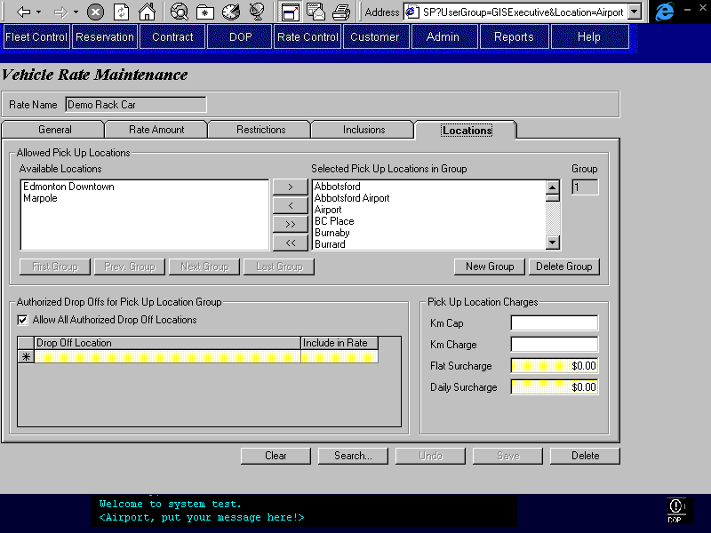
Purpose
The purpose of this tab is to identify the pick up locations for which the rate is available, and identify authorized drop off locations and various charges for those selected pick up locations.
The top section of the screen allows the user to select one or more pick up locations into a group for which properties will be defined. Multiple pick up location groups may be defined for each rate.
The next section allows for the selection of authorized drop off locations. If the ‘Allow All Authorized Drop Off Locations’ check box is not selected, each allowable drop off location and whether the drop off location charge is included in the rate must be specified. Any authorized drop off locations selected will be available for all the pick up locations in the group displayed at the top of the screen. Note that the pick up location is not a valid drop off location for itself unless it is identified as an authorized drop off location.
If the ‘Allow All Authorized Drop Off Locations’ check box is selected, the rate will be valid for all authorized locations identified in the Location Maintenance screen for the specified pick up location. The authorized charge will be charged for all the authorized drop off locations and cannot be included in the rate. This checkbox must be set for each pick up location group identified in the rate.
The last section allows for the Km cap, Km charge, flat surcharge, and daily surcharge to be set for the pick up location group displayed at the top of the screen. If the Km cap and Km charge fields are left blank then the values used for calculation will default to the values entered in the Rate Amount tab.
Navigation
N/A
Functions
First Group: Displays the first group of pick up locations.
Previous Group: Displays the previous group of pick up locations with reference to the current group being viewed.
Next Group: Displays the next group of pick up locations with reference to the current group being viewed.
Last Group: Displays the last group of pick up locations.
New Group: Clears the tab and allows the user to define a new location group.
Delete Group: Deletes the group of pick up locations currently being viewed.
Controls
Field | Source | Req* | Validation | Comments
Available Locations | Location, Location ID |  | Only include locations where both Rental Location and Allow Reznet Reservation are Yes. | Location name is displayed.
Selected Pick Up Locations in Group | Rate Location Set Member, Location ID | N | Value controlled by Locations available in the Available Locations list (see above). | Location name is displayed.
Group | Rate Location Set, Rate Location Set ID | D
Km Cap | Rate Location Set, Km Cap | N | Numeric | Used as an override if entered.
Km Charge | Rate Location Set, Per Km Charge | N | Currency | Used as an override if entered.
Flat Surcharge | Rate Location Set, Flat Surcharge | Y | Currency | Default: $0.00
Daily Surcharge | Rate Location Set, Daily Surcharge | Y | Currency | Default: $0.00
Allow All Authorized Drop Off Locations | Rate Location Set, Allow all authorized drop off locations | N |  | Default: No
Drop Off Location | Rate Drop Off Location, Location ID | N | Value controlled by Location table. Only include locations where Rental Location is Yes. | Location name is displayed.
Include in Rate | Rate Drop Off Location, Include in Rate | S | Yes, No | Default: No  Required if a Drop Off Location is specified.
Technical Notes

Rate Search
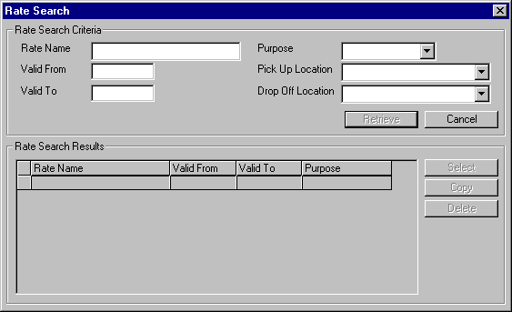
Purpose
This screen allows the user to search for rates so that they may be selected, edited, copied, or deleted.
The upper portion of the screen contains the available search parameters. Upon completing the search, a resulting list is displayed on the lower portion of the screen. The user may select one rate from this list and then return to the screen that called the search. If the search was invoked from the Vehicle Rate Maintenance Screen (not from another screen or button), then the user may choose to Copy or Delete (archive).
Navigation
Select: Returns to the screen from where the search was called and populates the appropriate fields with the selected rate information.
Functions
Retrieve: Searches for vehicle rates based on the search parameters entered. Displays the resulting set of rates in the list on the lower portion of the screen.
Copy: Create a new rate and copy all information except the Rate Name, Valid To and From dates, and Audit Information from the selected rate. Return to the Vehicle Rate Maintenance Screen, display the copied rate and prompt the user to enter a Rate Name and Valid To and From dates. This button is enabled only when this screen is invoked from the Vehicle Rate Maintenance screen ‘Search…’ button.
Delete: Flags the rate as deleted. The rate can only be deleted if a reservation or contract is not using it. Deleted rates cannot be searched on. This button is enabled only when this screen is invoked from the Vehicle Rate Maintenance screen ‘Search…’ button.
Controls
Field | Source | Req* | Validation | Comments
Rate Search Criteria
Rate Name | Vehicle Rate, Rate Name | N | Free form text
Valid From | Rate Availability, Valid From | N | Date
Valid To | Rate Availability, Valid To | N | Date
Purpose | Vehicle Rate, Rate Purpose ID | N | Value controlled by Rate Purpose table. | Purpose name is displayed.
Pick Up Location | Rate Location Set Member, Location ID | N | Value controlled by Location table. | Location name is displayed.
Drop Off Location | Rate Drop Off Location, Location ID | N | Value controlled by Location table. | Location name is displayed.
Rate Search Results
Rate Name | Vehicle Rate, Rate Name | D
Purpose | Vehicle Rate, Rate Purpose ID | D |  | Purpose name displayed.
Valid From | Rate Availability, Valid From | D |  | For selected vehicle rate.
Valid To | Rate Availability, Valid To | D |  | For selected vehicle rate.
Technical Notes
The Valid To and From search criteria should return all vehicle rates with valid periods that intersect the Valid To and From dates specified in the search. That is, the Valid To date >= the specified search Valid From date, and the Valid From date <= the specified search Valid To date. Note: If both From and To Date are entered, only rates that are valid for the entire From/To period will be returned.
Rates returned should only be rates that have not been superseded.

Location Maintenance
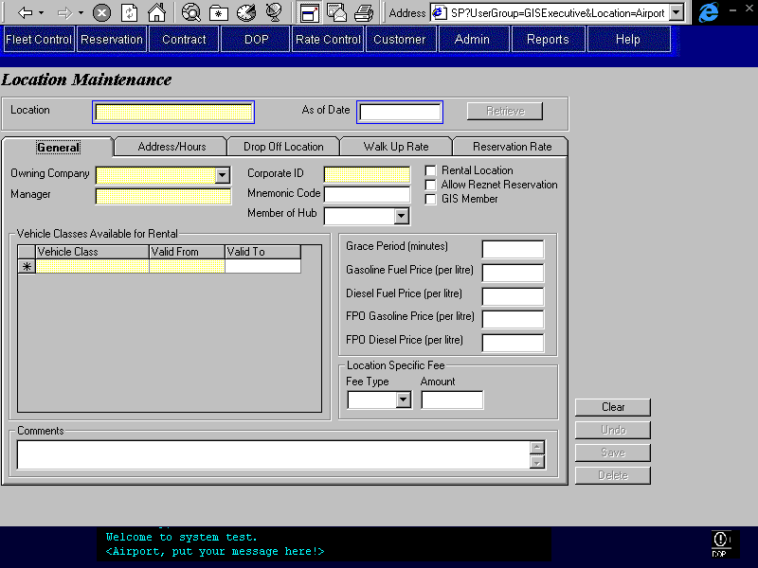
Purpose
This screen allows for the creation and maintenance of Budget Locations, and for definition of information that is location dependent.
Five tabs are used to classify the information on the screen:
General: Where basic information about the location is entered. This is general information whose value varies with location.
Address/Hours: Where the location address and hours of service are defined.
Drop Off Location: Where Drop Off Locations and associated charges defined.
Walk Up Rate: Where Rate and Level are assigned to each Vehicle Class for walk up customers at that location.
Reservation Rate: Where Rate and Level are assigned to each Vehicle Class for reservations for that location.
The Location name and a date are shown at the top of the screen and may be used to search for specific location information. The date entered will bring up the location information that is valid as of that date. If more than one match is found when a location is searched for, then a list will be displayed that may be selected from.
Navigation
N/A
Functions
Retrieve: Searches based on the entries in the Location Name field and the Date field, and then displays the applicable information on all the tabs. If more than one match is found then a list containing the location name, owning company, and city will be displayed to the user for selection.
Controls
Field | Source | Req* | Validation | Comments
Location | Location, Location | Y | Free form text,.  Must be unique. | Display only after location is saved for the first time.
As of Date |  | Y | Date | This will be used in the search to filter the records displayed in the tabs to those that are valid as of the entered date. Default: Current day.
Technical Notes

Location Maintenance – General Tab
Purpose
The General tab defines information or data that is specific to the selected location. This information includes the Owning Company, Location Manager, Corporate Location ID, Mnemonic Code, Hub that location is a member of, Available Vehicle Classes, Grace Period for returns, Fuel Price, Location Fee, and Comments.
Rental Location, Allow ResNet Reservation, and GIS Member flags are available to specify whether a location rents vehicles (rental location), whether ResNet takes reservation for the location (allow resnet reservation), and whether the location is using the GIS system (GIS member).
Grace Period is the amount of time that a returned vehicle may be late before being charged late charges. Fuel Price is the price per litre that is charged to customers when their returned vehicle must be refuelled at the drop off location. Gasoline, Diesel, FPO and Non-FPO prices are defined for fuel. Selected Vehicle Classes are the vehicle classes that the specified location offers for rental. Location Specific Fee is any fee that is charged by a particular location. For example, the airport locations charge an airport fee.
Navigation
N/A
Functions
N/A
Controls
Field | Source | Req* | Validation | Comments
Owning Company | Location, Owning Company | Y | Value controlled by Owning Company table. | Owning Company name is displayed.
Manager | Location , Manager | Y | Free form text
Corporate ID | Location, Corporate Location ID | Y | Numeric  Maximum 4 characters
Mnemonic Code | Location, Mnemonic Code | S |  | Required if Rental Location is Yes.
Member of Hub | Location, Hub | S | Value controlled by Hub table. | Required if Rental Location is Yes.
Rental Location | Location, Rental Location | N |  | Default: No
Allow RezNet Reservation | Location, ResNet Location | N |  | Default: No
GIS Member | Location, GIS Member | N |  | Default: No
Vehicle Class | Location Vehicle Class, Vehicle Class Code | S | Values controlled by Vehicle Class table. | If Rental Location is Yes then at least one vehicle class must be selected for a location. Vehicle Class Name is displayed.
Valid From | Location Vehicle Class, Valid From | S | Date  Cannot be backdated | Required if Vehicle Class is selected for row.
Valid To | Location Vehicle Class, Valid To | S | Date  Cannot be backdated  Cannot overlap another record. | Required if there is a record with a more recent Valid From date for the same Vehicle Class.
Grace Period | Location, Grace Period | S | Numeric (unit is minutes) | Required if Rental Location is Yes.
Gasoline Fuel Price | Location, Gasoline Price per Litre | S | Numeric | Required if Rental Location is Yes.
Diesel Fuel Price | Location, Diesel Price per Litre | S | Numeric | Required if Rental Location is Yes.
FPO Gasoline Fuel Price | Location, FPO Gasoline Price per Litre | S | Numeric | Required if Rental Location is Yes.
FPO Diesel Fuel Price | Location, FPO Diesel Price per Litre | S | Numeric | Required if Rental Location is Yes.
Location Specific Fee – Fee Type | Location, Fee Type | S | None, Percent, Flat | Required if Amount is entered. This field determines whether there is a fee and whether the fee is stored as a percentage or as a flat amount.
Location Specific Fee – Amount | Location, Flat Fee  OR  Location, Percentage Fee | S | Currency  OR  Numeric (percent) | Required if Fee Type is Percent or Flat
Comments | Location, Remarks | N | Free form text
Technical Notes
Valid From / Valid To:
- Backdating is not allowed
- No overlap allowed between Valid From and To periods for the same vehicle class
- Contiguity is not required

Location Maintenance – Address/Hours Tab
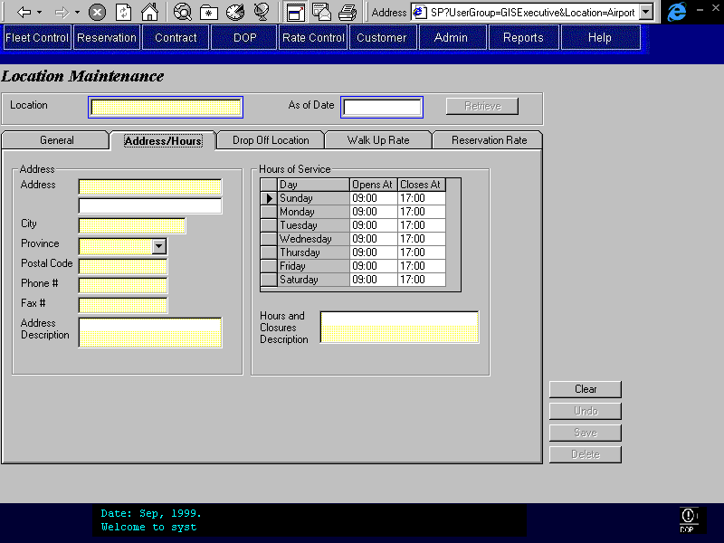
Purpose
The purpose of this tab is to define the Location Address and Hours of Service.
The exact address and hours are recorded as well as a more general description, which is used by the application for describing the location and hours to the customer. The description may also include any special closures of the location.
Navigation
N/A
Functions
N/A
Controls
Field | Source | Req* | Validation | Comments
Address
Address (line one) | Location, Address 1 | Y | Free form text.
Address (line two) | Location, Address 2 | N | Free form text.
City | Location, City | Y | Free form text.
Province | Location, Province | Y | Value controlled by the Province/State table.
Postal Code | Location, Postal Code | Y
Phone # | Location, Phone Number | Y
Fax # | Location, Fax Number | Y
Address Description | Location, Address Description | Y | Free form text.
Hours of Service
Day | Hours of Service, Day of Week | D | Pre-selected and cannot be updated. Values are the days of the week. | One of each value is displayed and cannot be updated by the user.
Opens At | Hours of Service, Opens At | N | Time (24 hr) | Must be less than or equal to the Closing time for the same day.
Closes At | Hours of Service, Closes At | N | Time (24 hr) | Must be greater than or equal to the Opening time for the same day.
Hours and Closures Description | Location, Hours of Service Description | Y | Free form text. | This will be displayed for all reservations and contracts for this pick location. It should match the opening and closing hours for each day of the week. This cannot be checked by GIS and must be done manually.
Technical Notes

Location Maintenance – Drop Off Location Tab
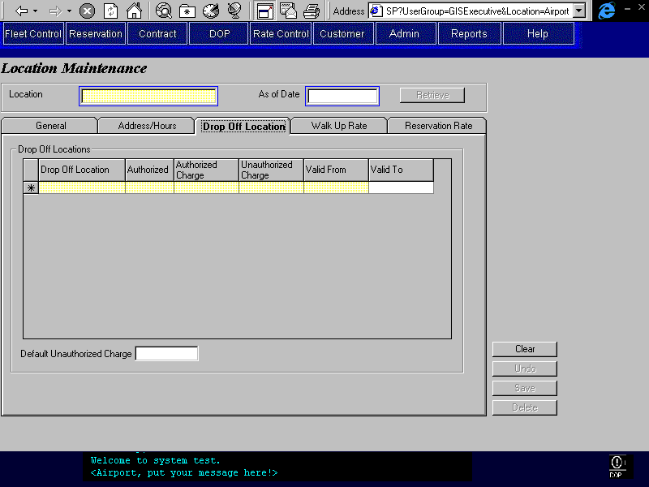
Purpose
The purpose of this tab is to define the drop off charges for all rentals where a vehicle is picked up at this location and dropped off at another location.
Drop Off Locations are selected in the first column and then whether or not that location is authorized and the associated authorized and unauthorized drop charges are entered along with the valid from and to dates.
A default unauthorized charge must also be specified. This will be used for all drop off locations that are not individually selected.
Navigation
N/A
Functions
N/A
Controls
Field | Source | Req* | Validation | Comments
Drop Off Location | Pick Up/Drop Off Location, Drop Off Location ID | N | Value controlled by Location table. | Where the currently selected Location is the Pick Up/Drop Off Location, Pick Up Location ID.  Location name is displayed.
Authorized | Pick Up/Drop Off Location, Authorized | S | Yes/No | Required if a Drop Off Location is selected for the row.
Authorized Charge | Pick Up/Drop Off Location, Authorized Charge | S | Currency | Required if a Drop Off Location is selected for the row.
Unauthorized Charge | Pick Up/Drop Off Location, Unauthorized Charge | S | Currency | Required if a Drop Off Location is selected for the row.
Valid From | Pick Up/Drop Off Location, Valid From | S | Date | Required if a Drop Off Location is selected for the row.
Valid To | Pick Up/Drop Off Location, Valid To | S | Date | Required if record is superseded.
Default Unauthorized Charge | Location, Default Unauthorized Drop Off Charge | S | Currency | Required if Rental Location is Yes.
Technical Notes
Valid From / Valid To:
- Backdating is not allowed
- No overlap allowed between Valid From and To periods for the same drop off location
- Contiguity is not required

Location Maintenance – Walk Up Rate Tab
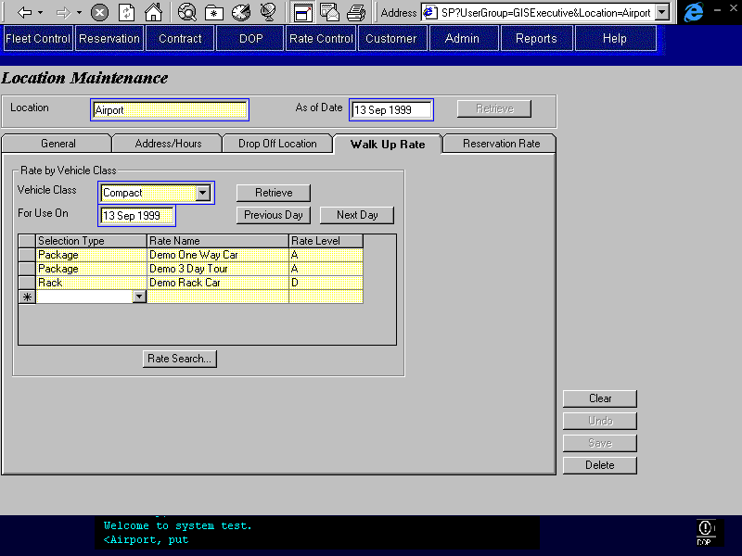
Purpose
This tab allows for the assignment of Rates and Rate Levels by vehicle class for walk up rentals at the specified location.
For each Vehicle Class available at the specified location, several rates and levels may be assigned. Each rate/level is assigned a selection type that is later used for classification for presentation to the customer service representative. If rates are entered for a vehicle class then one and only one of the selection types must be ‘Rack’.
Navigation
Rate Search: Invokes the rate search screen and returns the selected rate to the Rate Name and Rate Level fields in the active row.
Functions
Retrieve: Populates the Rate by Vehicle Class fields with information for the selected Vehicle Class and Date. If the vehicle class and day being retrieved does not have any rates assigned then GIS will ask the user if they want to copy the rates from the vehicle class and day currently being displayed (provided that they have rates assigned).
Prev Day: Retrieves the record for the previous day. Displays the previous day date in the ‘For Use On’ field. If the previous day being retrieved does not have any rates assigned then GIS will ask the user if they want to copy the rates from the day that is currently being displayed (provided that it has rates).
Next Day: Retrieves the record for the next day. Displays the next day date in the ‘For Use On’ field. If the next day being retrieved does not have any rates assigned then GIS will ask the user if they want to copy the rates from the day that is currently being displayed (provided that it has rates).
Controls
Field | Source | Req* | Validation | Comments
Vehicle Class | Location Vehicle Rate Level, Location Vehicle Class ID | Y | Value controlled by Location Vehicle Class, Vehicle Class Code. | Vehicle Class Name is displayed.
For Use On | Location Vehicle Rate Level, Valid From | Y | Day Date | Default: Current Day
Selection Type | Location Vehicle Rate Level, Rate Selection Type | Y | Rack, Package, and Promotion. | One and only one row is required with value = Rack. See technical note below.
Rate Name | Location Vehicle Rate Level, Rate ID | S | Value controlled by Vehicle Rate table. | Required if Selection Type entered. Display Rate Name.
Rate Level | Location Vehicle Rate Level, Rate Level | S | Value controlled by Rate Level table for selected Rate. | Required if Selection Type is entered.
Technical Notes
One and only one Rack rate must be entered for each Vehicle Class available at the specified location. There is no restriction on Promotion or Package.
For each Vehicle Class available at the specified location, the Valid From and To periods must not overlap. If a vehicle class is not available for a period of time (controlled in the Location Maintenance General tab) it will not be possible to set walk up rates for that time period.
For all values entered into the Location Vehicle Rate Level table using this screen, Location Vehicle Rate Level, Location Vehicle Rate Type = Walk Up

Location Maintenance – Reservation Rate Tab
Location Maintenance – Reservation Rate Tab – Same Day Sub-Tab
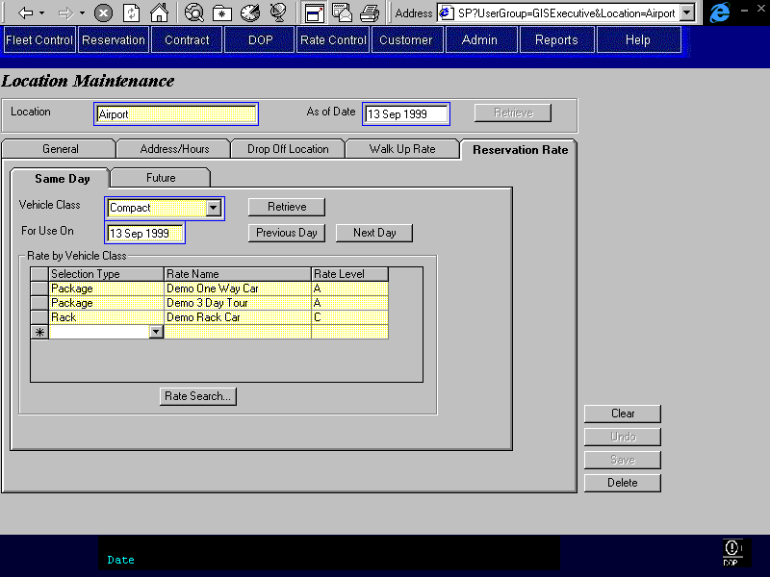
Purpose
This tab allows for the assignment of Rates and Rate Levels by vehicle class for same day reservations for pick up at the specified location.
For each Vehicle Class available at the specified location, several rates and levels may be assigned. Each rate/level is assigned a selection type that is later used for classification for presentation to the reservations agent or customer service representative. If rates are entered for a vehicle class then one and only one of the selection types must be ‘Rack’.
The ‘For Use On’ date controls which day the selected rates will be used for same day reservations.
Navigation
Rate Search: Invokes the rate search screen and returns the selected rate to the Rate Name and Rate Level fields in the active row.
Functions
Retrieve: Populates the Rate by Vehicle Class fields with information for the selected Vehicle Class and Date. If the vehicle class and day being retrieved does not have any rates assigned then GIS will ask the user if they want to copy the rates from the vehicle class and day currently being displayed (provided that they have rates assigned).
Prev Day: Retrieves the record for the previous day. Displays the previous day date in the ‘For Use On’ field. If the previous day being retrieved does not have any rates assigned then GIS will ask the user if they want to copy the rates from the day that is currently being displayed (provided that it has rates).
Next Day: Retrieves the record for the next day. Displays the next day date in the ‘For Use On’ field. If the next day being retrieved does not have any rates assigned then GIS will ask the user if they want to copy the rates from the day that is currently being displayed (provided that it has rates).
Controls
Field | Source | Req* | Validation | Comments
Vehicle Class | Location Vehicle Rate Level, Location Vehicle Class ID | Y | Value controlled by Location Vehicle Class, Vehicle Class Code. | Vehicle Class Name is displayed.
For Use On | Location Vehicle Rate Level, Valid From | Y | Day Date | Default: Current Day
Selection Type | Location Vehicle Rate Level, Rate Selection Type | Y | Rack, Package, and Promotion. | One and only one row is required with value = Rack. See technical note below.
Rate Name | Location Vehicle Rate Level, Rate ID | S | Value controlled by Vehicle Rate table. | Required if Selection Type entered. Display Rate Name.
Rate Level | Location Vehicle Rate Level, Rate Level | S | Value controlled by Rate Level table for selected Rate. | Required if Selection Type is entered.
Technical Notes
One and only one Rack rate must be entered for each Vehicle Class/Valid From and To combination. There is no restriction on Promotion or Package.
For each Vehicle Class available at the specified location, the Valid From and To periods must not overlap. If a vehicle class is not available for a period of time (controlled in the Location Maintenance General tab) it will not be possible to set same day reservation rates for that time period.
For all values entered into the Location Vehicle Rate Level table using this screen, Location Vehicle Rate Level, Location Vehicle Rate Type = Same Day
Location Maintenance – Reservation Rate Tab – Future Sub-Tab
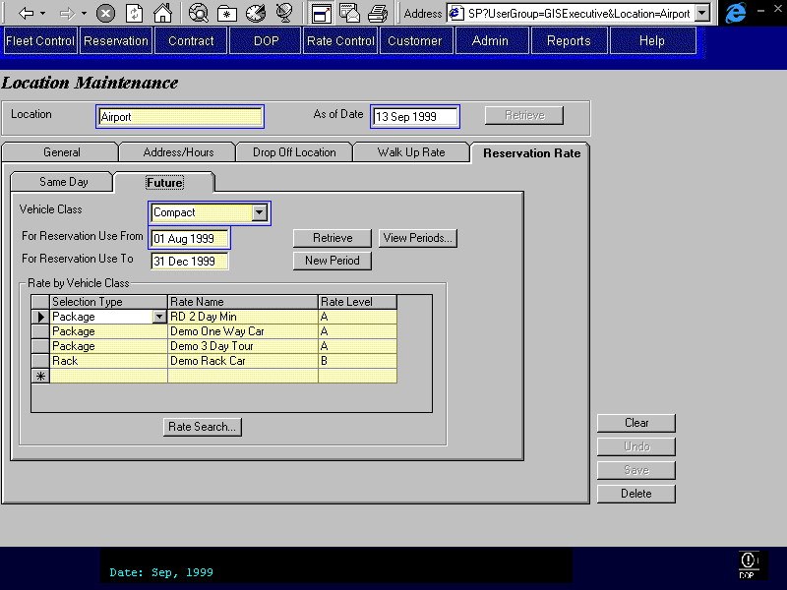
Purpose
This tab allows for the assignment of Rates and Rate Levels by vehicle class for future reservations for vehicle pick up at the specified location.
For each Vehicle Class available at the specified location, several rates and levels may be assigned. Each rate/level is assigned a selection type that is later used for classification for presentation to the reservations agent or customer service representative. If rates are entered for a vehicle class then one and only one of the selection types must be ‘Rack’.
The ‘For Reservation Use’ From and To dates define when reservations may use the selected rates for making reservations. The pick up date of the reservation determines which assigned future reservation rate will be used. The period for which the rate itself is valid is controlled in the rate definition.
Navigation
Rate Search: Invokes the rate search screen and returns the selected rate to the Rate Name and Rate Level fields in the active row.
View Periods: Opens a dialogue box that shows all the Future Reservation Rate Time Periods starting on or after the current Valid From date. Returns the selected time period to the sub-tab.
Functions
Retrieve: Populates the Rate by Vehicle Class fields with information for the selected Vehicle Class and Valid From and To dates. The Valid From/To period that contains the date specified in Valid From will be returned. If no Valid From/Valid To dates are specified then the most recent information will be returned and the Valid From/To dates will be populated accordingly.
New Period: Sets Valid From to the day after the current Valid to and clears Valid To and all the Rates by Vehicle Class fields. GIS will also ask the user if they wish to copy the rates from the current period displayed on the screen.
Controls
Field | Source | Req* | Validation | Comments
Vehicle Class | Location Vehicle Rate Level, Location Vehicle Class ID | Y | Value controlled by Location Vehicle Class, Vehicle Class Code. | Vehicle Class Name is displayed.
Selection Type | Location Vehicle Rate Level, Rate Selection Type | Y | Rack, Package, and Promotion. | One and only one row is required with value = Rack. See technical note below.
Rate Name | Location Vehicle Rate Level, Rate ID | N | Value controlled by Vehicle Rate table. | Required if Selection Type entered. Display Rate Name.
Rate Level | Location Vehicle Rate Level, Rate Level | N | Value controlled by Rate Level table for selected Rate. | Required if Selection Type is entered.
For Reservation Use From | Location Vehicle Rate Level, Valid From | N | Date | Required if Selection Type is entered.
For Reservation Use To | Location Vehicle Rate Level, Valid To | N | Date | Required if Selection Type is entered.
Technical Notes
One and only one Rack rate must be entered for each Vehicle Class/Valid From and To combination. There is no restriction on Promotion or Package.
For each Vehicle Class available at the specified location, the Valid From and To periods must not overlap. If a vehicle class is not available for a period of time (controlled in the Location Maintenance General tab) it will not be possible to set future reservation rates for that time period.
For all values entered into the Location Vehicle Rate Level table using this screen, Location Vehicle Rate Level, Location Vehicle Rate Type = Future

Optional Extra Maintenance
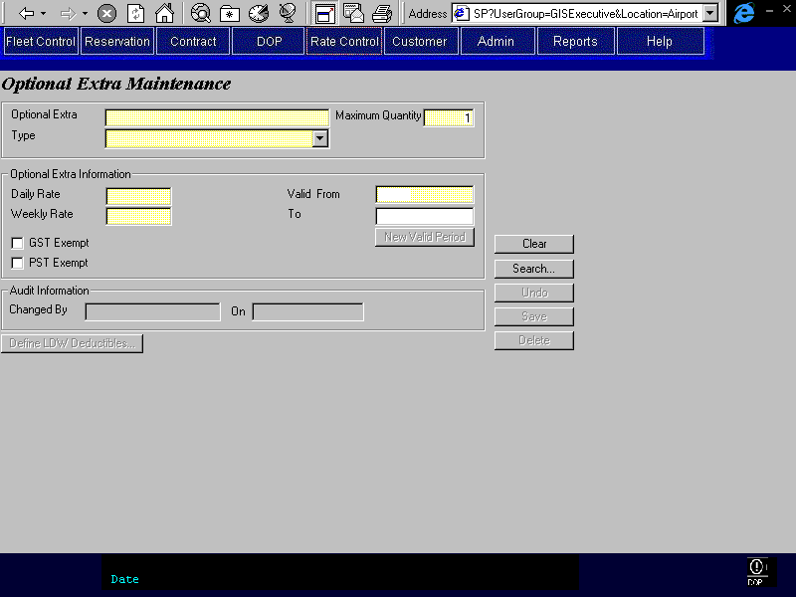
Purpose
This screen allows for the definition of Optional Extras and their associated fees, and taxes. These optional extras may be referenced for use in reservations and contracts.
The Optional Extra name is shown at the top of the screen. Valid From and To dates are required for each entry. For each Optional extra, Optional Extra Type is selected; Daily Rate and Weekly Rate amounts are entered; and whether GST or PST is exempt is specified. Audit information is visible at the bottom of the screen.
Optional Extra information may be searched on via the Optional Extra name, type, and Valid From and To dates.
Navigation
LDW Deductibles: Invokes the LDW Deductible screen where LDW deductibles are defined by vehicle class. This button is enabled only when the Optional Extra Type is LDW.
Save: Opens the LDW Deductible screen if the optional extra has Type LDW.
Functions
New Valid Period: Allows the user to create a new Valid To/From period. Defaults the new Valid From date with the day after the old Valid To date. If the Valid To date is null then the user will be forced to enter it before creating a new time period.
Controls
Field | Source | Req* | Validation | Comments
Optional Extra | Optional Extra, Optional Extra | Y | Free form text
Type | Optional Extra, Type | Y | Controlled by the Optional Extra Type table.
Valid From | Optional Extra Price, Optional Extra Valid From | Y | Date
Valid To | Optional Extra Price, Valid To | S | Date | Required if the record is superseded.
Daily Rate | Optional Extra Price, Daily Rate | Y | Currency
Weekly Rate | Optional Extra Price, Weekly Rate | Y | Currency
Maximum Quantity | Optional Extra , Maximum Quantity | Y | Numeric | Default 1
GST Exempt | Optional Extra Price, GST Exempt | N |  | Default: False
PST Exempt | Optional Extra Price, PST Exempt | N |  | Default False
Changed By | Optional Extra Price, Last Changed By | D
Changed On | Optional Extra Price, Last Changed On | D
Technical Notes
When a new Optional Extra of Type LDW is created the user should be forced to define the LDW deductibles before exiting the Optional Extra Screen. This is done by having the save button invoke the LDW Deductible screen when the optional extra type is ‘LDW’.
Valid From / Valid To:
- Backdating is not allowed
- No overlap allowed between Valid From and To periods
- Contiguity is not required
When the Valid From date is updated a message will be displayed to the user to confirm that they want to update the Valid From date and not create a new valid period.
The Valid To and From search criteria should return all optional extras with Valid periods that intersect the Valid To and From dates specified in the search. That is, the Valid To date >= the specified search Valid From date, and the Valid From date <= the specified search Valid To date.

Optional Extra Maintenance – LDW Deductibles
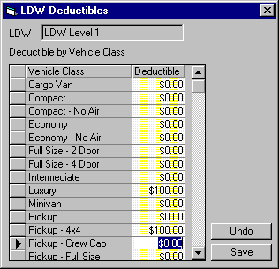
Purpose
This screen allows for the definition of LDW deductibles by vehicle class for the LDW optional extra shown at the top of the screen.
This screen is invoked from the Optional Extra Screen, where the LDW optional extra (displayed at the top of this screen) is specified. Vehicle Classes are displayed in the left column. Each vehicle class is displayed once so that a deductible (right column) may be specified for each one.
Navigation
N/A
Functions
N/A
Controls
Field | Source | Req* | Validation | Comments
LDW | LDW Deductible, Optional Extra ID | D |  | Optional Extra name is displayed.
Vehicle Class | LDW Deductible, Vehicle Class Code | D | Pre-select, cannot be updated. Values displayed are one of each currently existing Vehicle Class. | One of each value is displayed and cannot be updated by the user.
Deductible | LDW Deductible, LDW Deductible | Y | Currency | Required for each Vehicle Class.
Technical Notes
When a new Vehicle Class is added, the LDW deductible table entries should be automatically created. A reminder should be issued to the user to update the LDW deductibles. The next time the LDW deductibles are viewed in the LDW deductible screen, the user will be forced to enter a deductible for the new vehicle class.
When a new Optional Extra of Type LDW is created the user should be forced to define the LDW deductibles before exiting the Optional Extra Screen. This is done by having the save button invoke the LDW Deductible screen when the optional extra type is ‘LDW’.

Sales Accessory Maintenance
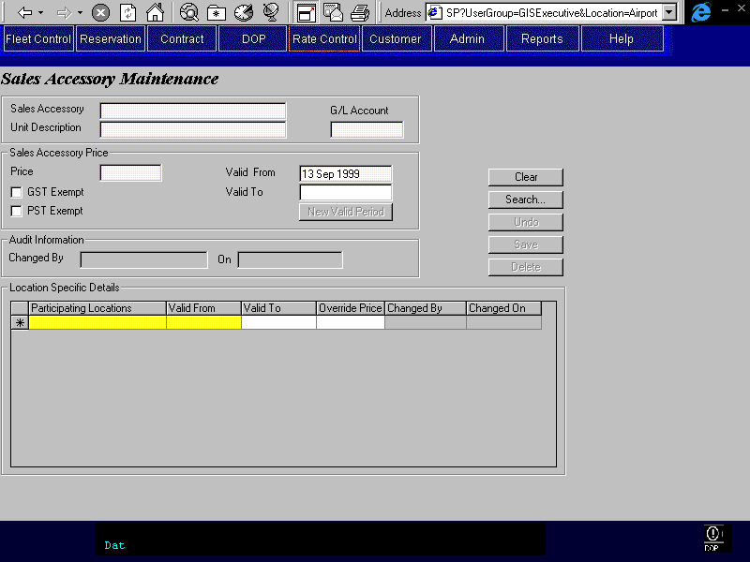
Purpose
This screen allows for the definition of Sales Accessories and their associated fees, and taxes. The Sales Accessory’s price may also be defined by location. These accessories can be referenced for use in contracts and reservations.
Sales Accessory Name, Unit Description, and Price are entered for each Sales Accessory along with Valid To and From dates, and whether the sales accessory is exempt from GST or PST. Location specific information may then be entered for each Sales Accessory. The locations that offer the Sales Accessory are added to the Participating Locations List. Then for each participating location, a location specific price may also be specified in the Override Price field. Audit information is visible for each sales accessory and for each participating location.
Sales Accessory information may be searched on using the Sales Accessory name, Unit Description, and Valid From and To dates.
Navigation
N/A
Functions
New Valid Period: Allows the user to create a new Valid To/From period. Defaults the new Valid From date with the day after the old Valid To date. If the Valid To date is null then the user will be forced to enter it before creating a new time period. Copy all the participating locations for the sales accessory record with the most recent Valid From prior to the new Valid From, and set the Valid From/To period for each participating location to the new Valid From/To period.
Controls
Field | Source | Req* | Validation | Comments
Sales Accessory | Sales Accessory, Sales Accessory | Y | Free form text
Unit Description | Sales Accessory, Unit Description | Y | Free form text
G/L Account | Sales Accessory, G/L Revenue Account | Y | Free form text
Price | Sales Accessory Price, Price | Y | Currency
Valid From | Sales Accessory Price, Sales Accessory Valid From | Y | Date | Default to current date.
Valid To | Sales Accessory Price, Valid To | S | Date | Required if record is superseded.
GST Exempt | Sales Accessory Price, GST Exempt | N |  | Default: False
PST Exempt | Sales Accessory Price, PST Exempt | N |  | Default False
Changed By (sales accessory) | Sales Accessory Price, Last Changed By | D
Changed On (sales accessory) | Sales Accessory Price, Last Changed On | D
Location Specific Details |  |  |  | Only records where the Valid To is greater than or equal to the current Valid From for the sales accessory will be displayed.
Participating Locations | Location Sales Accessory, Location ID | Y | Values controlled by the Location table. | Location name is displayed.
Valid From (override price) | Location Sales Accessory, Valid From | S | Date | Required if Location is entered.
Valid To (override price) | Location Sales Accessory, Valid To | S | Date | Required if the record is superseded.
Override Price | Location Sales Accessory, Price | S | Currency | The location override Valid From and To dates must be inside the sales accessory default From and To dates, otherwise an override price is required.
Changed By (location sales accessory) | Location Sales Accessory, Last Changed By | D
Changed On (location sales accessory) | Location Sales Accessory, Last Changed On | D
Technical Notes
Valid From / Valid To:
- Backdating is not allowed
- No overlap allowed between Valid From and To periods
- Contiguity is not required
When the Valid From date is updated a message will be displayed to the user to confirm that they want to update the Valid From date and not create a new valid period.
The Valid To and From search criteria should return all Sales Accessories with Valid periods that intersect the Valid To and From dates specified in the search. That is, the Valid To date >= the specified search Valid From date, and the Valid From date <= the specified search Valid To date.

Exchange Rate Maintenance
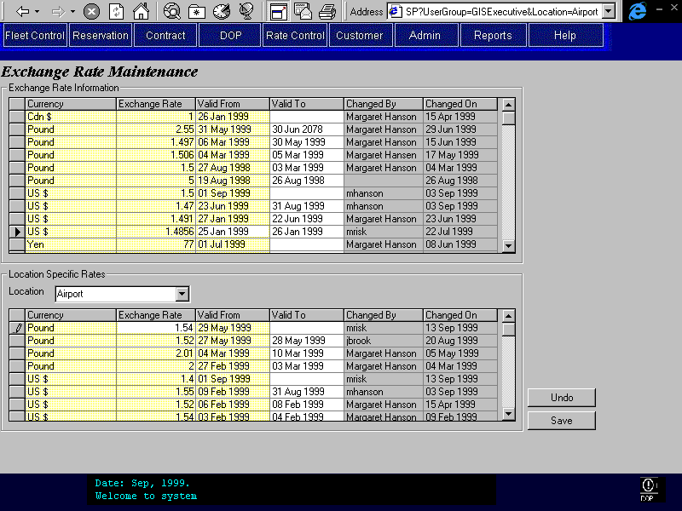
Purpose
This screen allows for the definition of Exchange Rates. These rates will be used for any transaction with foreign funds. Location specific Exchange Rates may also be defined and will override, for the specified location, the standard or default Exchange Rates.
Standard or default Exchange Rates are entered in the top section of the screen. Location specific Exchange Rates are entered in the lower portion of the screen. The various currencies are listed in the column on the left with the exchange rate relative to Canadian dollars listed on the right. Valid From and To dates are included with each entry. Last Changed Audit information is visible in the last two columns. The entries will be sorted first by currency (ascending) and then by Valid From date (descending). The exchange rates will be expressed as a multiple of Canadian dollars.
Navigation
N/A
Functions
Retrieve: Searches for and displays location specific exchange rate information using the location name. There is no button for this function since this is automatically invoked when a new location is selected.
Controls
Field | Source | Req* | Validation | Comments
Currency | Exchange Rate, Currency ID | N | Value controlled by Currency & Voucher Currency tables. | Display Currency name.
Exchange Rate | Exchange Rate, Rate | S | Numeric (percentage) | Required if currency entered for row.
Valid From | Exchange Rate, Exchange Rate Valid From | S | Date | Required if currency entered for row.
Valid To | Exchange Rate, Valid To | S | Date | Required if record is superseded and must be contiguous.
Changed By | Exchange Rate, Last Changed By | D
Changed On | Exchange Rate, Last Changed On | D
Location Specific
Location | Location Exchange Rate, Location ID | N | Value controlled by Location table. | Display Location name.
Currency | Location Exchange Rate, Currency ID | N | Value controlled by Currency table & Voucher Currency tables.. | Display Currency name.
Exchange Rate | Location Exchange Rate, Rate | S | Numeric (percentage) | Required if Currency (location specific) is entered.
Valid From | Location Exchange Rate, Valid From | S | Date | Required if Currency (location specific) is entered.
Valid To | Location Exchange Rate, Valid To | S | Date | Required if record is superseded.
Changed By | Location Exchange Rate, Created By | D
Changed On | Location Exchange Rate, Created On | D
Technical Notes
Valid From / Valid To:
- Backdating is not allowed
- No overlap allowed between Valid From and To periods
- Contiguity is required for default exchange rates
- Contiguity is not required for location override exchange rates

Reports
Reports to be designed by Budget personnel at a future date.

Background Processes
N/A

Test Scenario List
- Provincial Government Rate
- Day 1 to 7 is at standard rate
- Rentals over 7 days receive 15% off all days
- Km drop off charge is applied, not standard calculated drop off charges
- Monthly Rate
- One month = 30 days
- Daily / Weekly Rate
- $40/day, and $240/week (week = 6 x daily rate)
- Best combination for customer should be calculated
- Three Day Package Rate
- Flat charge for three days
- Daily charge for days kept over three day limit
- First Day Free with Minimum Three Day Rental
- Use different rate if kept less than three days
- Second Day Free with Minimum Three Day Rental
- Use different rate if kept less than three days
- Wedding Package
- Restrictions on pick up and drop off times
- One Way First Day Rate
- First day incorporates drop charge
- Weekly rate also quoted but cannot be used for rentals less than seven days
- One Way First Day with Extra Day Rate
- Same as One Way First Day Rate plus cheaper daily rate for rentals 8 days and over.

Controls & Audit Trails
History of all changes to rates must be stored so that other entities that reference the rates (such as reservations) will not be affected by rate changes. Audit information of who updated and the date of update should also be stored for all rates.

Security Requirements
Usage of the rate screens is limited to a small group of users who define and assign rates. These users have full access to create, update, and delete (archive) rates. See the GIS Security Design document for more details.

Business Transaction Volumes
To be determined.

Tables without Maintenance Screens
This section is superseded by the Production System Maintained Files document.

System Values Table Entries
This section is superseded by the Production System Maintained Files document.

Data Model

Revision History

Version 2.00
- Clean up documentation and make consistent with the GIS standards.

